Aamir Patel

IS 215

DFD Workshop

Jim’s Sales Distribution System

Context DFD

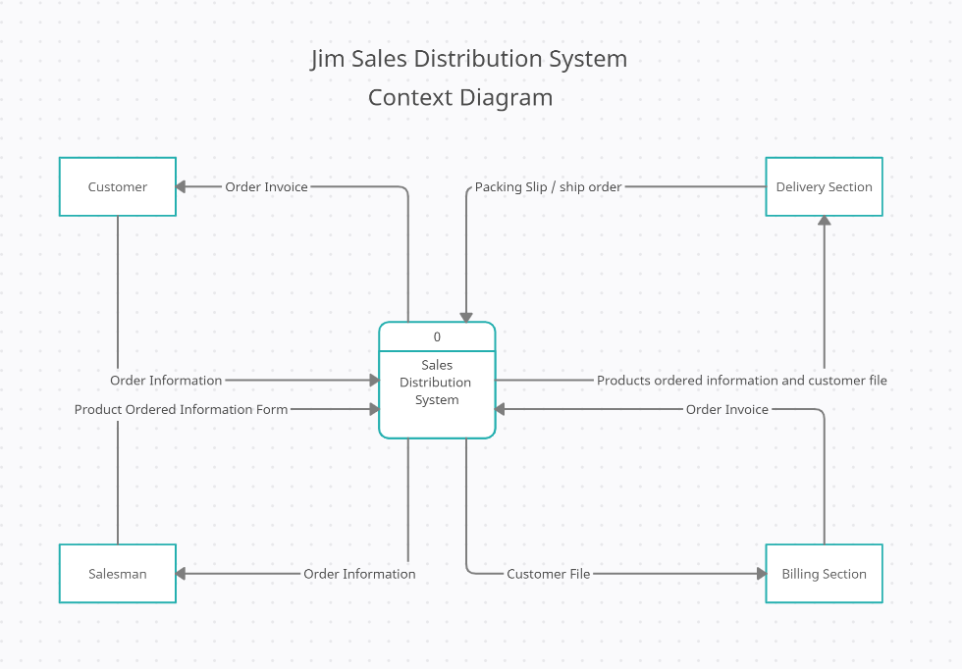

Level 0 DFD diagram

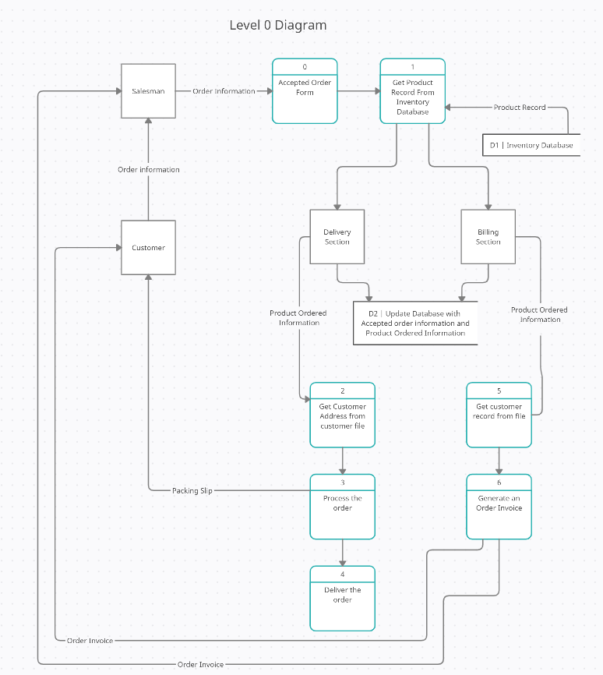

Functional Decomposition Diagram

